**Experiment No. 3b**

**Title :** Implementation of Fibonacci series using recursion

**Problem Statement :** Implementing Fibonacci series of any number using recursion

**Algorithm :**

**S1 :** Start

**S2 :** Declare an integer variable and a function fib ()

**S3 :** Call the function and send the value whose Fibonacci number has to be found.

**S4 :** In fib function if the integer is equal to 1 return 1 else call the function by sending the value of addition of (n-1) and (n-2).

**S5 :** Stop

**Code :**

#include<iostream>

using namespace std;

int fib(int n)

{

if(n<=1)

{

return(1);

}

else{

return((fib(n-1)+fib(n-2)));

}

}

int main()

{

int n,x;

cout<<"Enter the sequence end range : ";

cin>>n;

x = fib((n-1));

cout<<"Fibonacci digit is : "<<x;

}

**Output:**

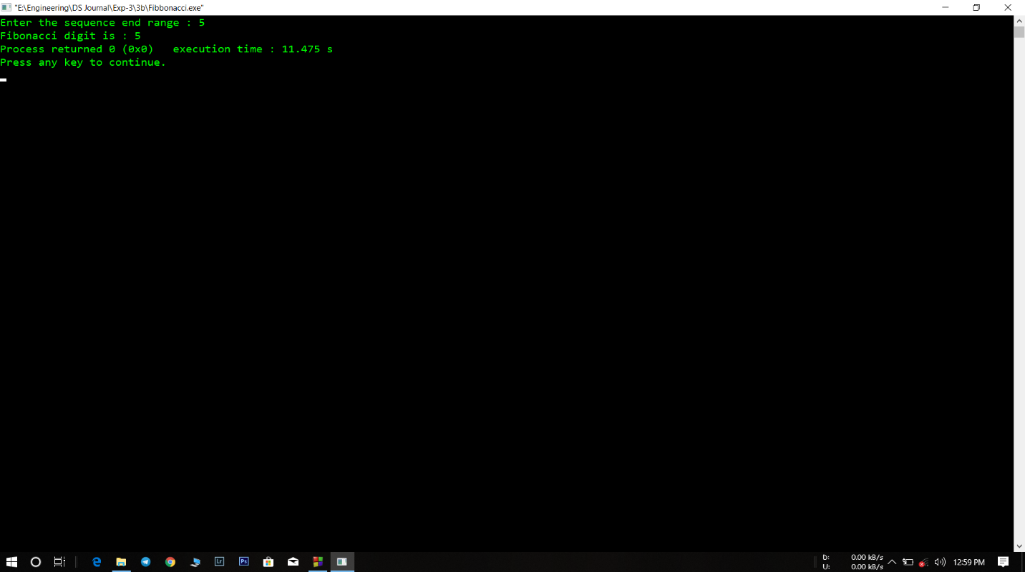

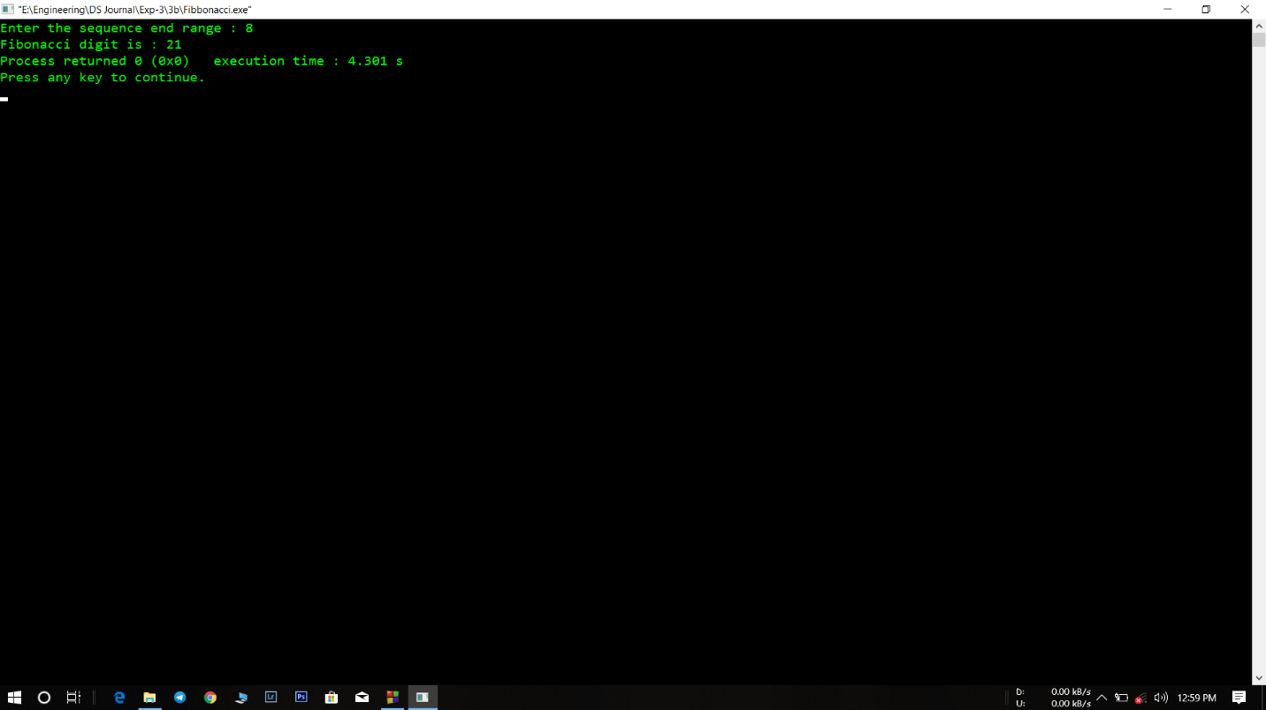

**Analysis :**

* Recursion process is little difficult to understand compared to looping.
* Program just sends the last number of the series and not the whole series.